

**American International University- Bangladesh**

**COE 3103: DATA COMMUNICATION**

**Mid Lab Report 02**

**Spring 2021-2022**

**Section: Q**

**Date: 17/02/2022**

**Submitted by,**

|  |  |
| --- | --- |
| Student Name | Student Id |
| Rahman, Sheikh Talha Jubayer | 19-41468-3 |

**Tasks**

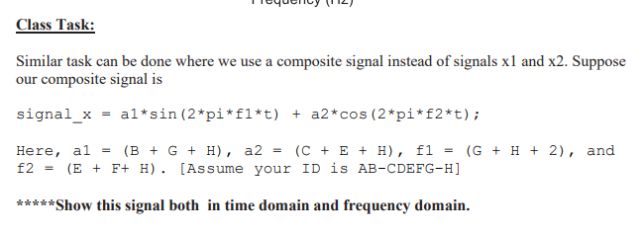

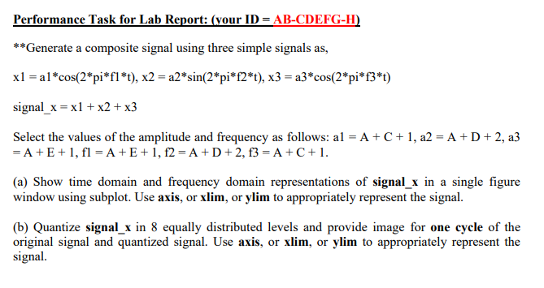

**Solution of Class Task (1)**

%ID: 19-41468-3

A = 1;

B = 9;

C = 4;

D = 1;

E = 4;

F = 6;

G = 8;

H = 3;

a1 = B+G+H; %a1 = 20

a2 = C+E+H; %a2 = 11

f1 = G+H+2; %f1 = 13

f2 = E+F+H; %f2 = 13

fs = 1000;

t = 0:1/fs:1;

signal_x = (a1*sin(2*pi*f1*t)) + (a2*cos(2*pi*f2*t));

subplot(2,1,1)

plot(t,signal_x)

axis([0 1 -30 30])

title('Time-Domain Representation of signal x')

xlabel('Time (s)')

ylabel('Amplitude')

fx = abs(fftshift(fft(signal_x)))/(length(signal_x)/2);

freq = linspace(-fs/2, fs/2, length(signal_x));

subplot(2,1,2)

bar(freq, fx,'linewidth',3)

axis([-20 20 0 30])

title('Frequency-Domain Representation of signal x')

xlabel('Frequency (Hz)')

ylabel('Amplitude')



**Solution of Performance Task (a)**

%ID: 19-41468-3

A = 1;

B = 9;

C = 4;

D = 1;

E = 4;

F = 6;

G = 8;

H = 3;

a1 = A+C+1; %a1 = 6

a2 = A+D+2; %a2 = 4

a3 = A+E+1; %a3 = 6

f1 = A+E+1; %f1 = 6

f2 = A+D+2; %f2 = 4

f3 = A+C+1; %f3 = 6

fs = 1000;

t = 0:1/fs:1;

x1 = a1*cos(2*pi*f1*t);

x2 = a2*sin(2*pi*f2*t);

x3 = a3*cos(2*pi*f3*t);

signal_x = x1+x2+x3;

subplot(2,1,1)

plot(t,signal_x)

axis([0 1 -20 20])

title('Time-Domain Representation of signal x')

xlabel('Time (s)')

ylabel('Amplitude')

fx = abs(fftshift(fft(signal_x)))/(length(signal_x)/2);

freq = linspace(-fs/2, fs/2, length(signal_x));

subplot(2,1,2)

bar(freq, fx,'linewidth',3)

axis([-10 10 0 15])

title('Frequency-Domain Representation of signal x')

xlabel('Frequency (Hz)')

ylabel('Amplitude')



**Solution of Performance Task (b)**

%ID: 19-41468-3

A = 1;

B = 9;

C = 4;

D = 1;

E = 4;

F = 6;

G = 8;

H = 3;

a1 = A+C+1; %a1 = 6

a2 = A+D+2; %a2 = 4

a3 = A+E+1; %a3 = 6

f1 = A+E+1; %f1 = 6

f2 = A+D+2; %f2 = 4

f3 = A+C+1; %f3 = 6

fs = 1000;

t = 0:1/fs:1;

x1 = a1*cos(2*pi*f1*t);

x2 = a2*sin(2*pi*f2*t);

x3 = a3*cos(2*pi*f3*t);

signal_x = x1+x2+x3;

p = linspace(-14,14,7);

c = linspace(-15.53,15.53,8);

[i,q] = quantiz(signal_x,p,c);

plot(t,signal_x,'x',t,q,'.')

axis([0 0.5 -16 16])

title('Quantization of signal x');

legend('Original signal','Quantized signal');

xlabel('Time (s)');

ylabel('Amplitude');

